|  |  |
| --- | --- |
| *Pacific Gas and Electric Company* | |
| Release 9.6 Installation Guide | |
|  |  |
|  |  |
| Project | ED AM/GIS |
|  |  |
| Prepared by | Ashish Narasimham |
| Date | 6/10/2015 |
| Version | 1.3 |
| Version Type | Final |

|  |  |  |  |
| --- | --- | --- | --- |
| Revision History | | | |
| Document # | Date | Author | Summary of Changes |
| 1.0 | 4/13/15 | Ashish Narasimham | Initial Document Creation |
| 1.1 | 4/30/15 | Roger Carribine | Finalized document for rollout to test |
| 1.2 | 6/9/15 | Roger Carribine | Updated section 20459 with additional step |
| 1.3 | 6/10/15 | Doug Brice | Replaced references to TFS20949 with TFS20594 |

# Introduction

## Purpose

This document is intended to detail the implementation and configuration steps required to implement Release 9.6 Installation Guide. This document describes the various configuration aspects required to complete any manual or automatic patch associated with this release. Each section in this document contains the steps required to patch the system in production.

## Terms Used

|  |  |
| --- | --- |
| OOTB | Out of the box. Unmodified from the commercial version. |
| TFS | Team Foundation Server |

## External Documents

Referenced are any external configuration documents or exports. These are documents that contain more detailed information about configuring a system or documents that can be loaded into an application to perform the configuration detailed in this document.

1. Supporting documentation folder
   1. \\sfetgis-nas01\sfgispoc_data\ApplicationDevelopment\IBM_Delivery\ReleaseInstructions\9.6

## List of Fixes

Below is the list of change requests detailing all fixes for the data model for this release:

|  |  |  |
| --- | --- | --- |
| **Item Number** | | **Title** |
| [20108](http://edappgistfsprd1:8080/tfs/web/wi.aspx?pcguid=15e9a9d1-95cb-4dd0-abfe-5af14ae6201f&id=20108) | | Master TFS DM 9.6 |
| [20072](http://edappgistfsprd1:8080/tfs/web/wi.aspx?pcguid=15e9a9d1-95cb-4dd0-abfe-5af14ae6201f&id=20072) | DM 9.6: Add a new value/name to the “PoleHeight” Domain 222 |
| [20067](http://edappgistfsprd1:8080/tfs/web/wi.aspx?pcguid=15e9a9d1-95cb-4dd0-abfe-5af14ae6201f&id=20067) | DM 9.6: Add New Members to Structure Size Domain |
| [19516](http://edappgistfsprd1:8080/tfs/web/wi.aspx?pcguid=15e9a9d1-95cb-4dd0-abfe-5af14ae6201f&id=19516) | DM 9.6: New Value for Joint Pole Members Auburn PAR #89767 |
| [19469](http://edappgistfsprd1:8080/tfs/web/wi.aspx?pcguid=15e9a9d1-95cb-4dd0-abfe-5af14ae6201f&id=19469) | DM 9.6: PAR #86070 New Value for Secondary Voltage Domain |
| [19468](http://edappgistfsprd1:8080/tfs/web/wi.aspx?pcguid=15e9a9d1-95cb-4dd0-abfe-5af14ae6201f&id=19468) | DM 9.6: Maintentance Plat/AreaName Field PAR SF #89311 PAR Diablo #88989 |
| [19105](http://edappgistfsprd1:8080/tfs/web/wi.aspx?pcguid=15e9a9d1-95cb-4dd0-abfe-5af14ae6201f&id=19105) | DM 9.6: Add '4000' value to RatedAmps Domain |
| [17716](http://edappgistfsprd1:8080/tfs/web/wi.aspx?pcguid=15e9a9d1-95cb-4dd0-abfe-5af14ae6201f&id=17716) | DM 9.6: CCB Interface Needed : Create new Domain for Essential Customer Indicator |
| [20488](http://edappgistfsprd1:8080/tfs/web/wi.aspx?pcguid=15e9a9d1-95cb-4dd0-abfe-5af14ae6201f&id=20488) | DM 9.6: Updates to the DuctDefinition DuctSize and ActualSize fields |
| [20342](http://edappgistfsprd1:8080/tfs/web/wi.aspx?pcguid=15e9a9d1-95cb-4dd0-abfe-5af14ae6201f&id=20342) | DM 9.6: Make vent and fiber optic indicators visible on duct def (all subtypes) |
| [20532](http://edappgistfsprd1:8080/tfs/web/wi.aspx?pcguid=15e9a9d1-95cb-4dd0-abfe-5af14ae6201f&id=20532) | DM 9.6: Remove PGE Annotation Horizontal Alignment AU from On Update of 50 scale anno classes |
| [20459](http://edappgistfsprd1:8080/tfs/web/wi.aspx?pcguid=15e9a9d1-95cb-4dd0-abfe-5af14ae6201f&id=20459) | DM 9.6: Add CircuitColor field to tables |
| [20540](http://edappgistfsprd1:8080/tfs/web/wi.aspx?pcguid=15e9a9d1-95cb-4dd0-abfe-5af14ae6201f&id=20540) | Mark DistBusBar as non-traceable |
| [20552](http://edappgistfsprd1:8080/tfs/web/wi.aspx?pcguid=15e9a9d1-95cb-4dd0-abfe-5af14ae6201f&id=20552) | Update Duct feature class |
| [20553](http://edappgistfsprd1:8080/tfs/web/wi.aspx?pcguid=15e9a9d1-95cb-4dd0-abfe-5af14ae6201f&id=20553) | Add ActualSize field to Duct feature class |
| [20572](http://edappgistfsprd1:8080/tfs/web/wi.aspx?pcguid=15e9a9d1-95cb-4dd0-abfe-5af14ae6201f&id=20572) | Update Vault polygon ArcFM properties |
| [20610](http://edappgistfsprd1:8080/tfs/ElectricDistCollection/EDAMGIS/_workitems#_a=edit&id=20610) | Update conductor Insulation – UG Domain to reduce EPR-HYP code value length |
| [20737](http://edappgistfsprd1:8080/tfs/ElectricDistCollection/EDAMGIS/_workitems#_a=edit&id=20737) | Remove ULSTEXTFIELD model name from LABELTEXT field of SecUgConductor |
| [20738](http://edappgistfsprd1:8080/tfs/ElectricDistCollection/EDAMGIS/_workitems#_a=edit&id=20738) | Update Switch Annotation |
| [20752](http://edappgistfsprd1:8080/tfs/ElectricDistCollection/EDAMGIS/_workitems#_a=edit&id=20752) | Create PGE_CODES_AND_DESCRIPTIONS table for CYME |
| [20062](http://edappgistfsprd1:8080/tfs/ElectricDistCollection/EDAMGIS/_workitems#_a=edit&id=20062) | Add new Device Manufacturers |
| [20063](http://edappgistfsprd1:8080/tfs/ElectricDistCollection/EDAMGIS/_workitems#_a=edit&id=20063) | Add new members to SCADA Communication domain |
| [20065](http://edappgistfsprd1:8080/tfs/ElectricDistCollection/EDAMGIS/_workitems#_a=edit&id=20065) | Add new members to the Actuating Current Values domain |
| [20047](http://edappgistfsprd1:8080/tfs/ElectricDistCollection/EDAMGIS/_workitems#_a=edit&id=20047) | Communicating Fault Indicator and Line Sensor |
| [20060](http://edappgistfsprd1:8080/tfs/ElectricDistCollection/EDAMGIS/_workitems#_a=edit&id=20060) | Create New Domain: FI and LS Models |
| [20855](http://edappgistfsprd1:8080/tfs/ElectricDistCollection/EDAMGIS/_workitems#_a=edit&id=20855) | Configure Neutral Conductor for X-Section anno |
| [20611](http://edappgistfsprd1:8080/tfs/ElectricDistCollection/EDAMGIS/_workitems#_a=edit&id=20611) | Add new Source Side Device Fields and Configure |
| [20420](http://edappgistfsprd1:8080/tfs/ElectricDistCollection/EDAMGIS/_workitems#_a=edit&id=20420) | Remove ArcFM Structure Relate from DCRectifier and DistBusBar |
| [20558](http://edappgistfsprd1:8080/tfs/ElectricDistCollection/EDAMGIS/_workitems#_a=edit&id=20558) | Update Cached Tracing Tables |
| [20589](http://edappgistfsprd1:8080/tfs/ElectricDistCollection/EDAMGIS/_workitems#_a=edit&id=20589) | ED50 Configuration for Network Protector |
| [20768](http://edappgistfsprd1:8080/tfs/ElectricDistCollection/EDAMGIS/_workitems#_a=edit&id=20768) | Modify ArcFM Properties to support Circuit ID UI |
| [20851](http://edappgistfsprd1:8080/tfs/ElectricDistCollection/EDAMGIS/_workitems#_a=edit&id=20851) | Create Circuit Color Field on Primary Conductor |
| [20933](http://edappgistfsprd1:8080/tfs/ElectricDistCollection/EDAMGIS/_workitems#_a=edit&id=20933) | Populate Circuit Color Field on Primary Conductor |
| [20594](http://edappgistfsprd1:8080/tfs/ElectricDistCollection/EDAMGIS/_workitems#_a=edit&id=20594) | Map Production 1.0 at 10.2.1 |
| [21130](http://edappgistfsprd1:8080/tfs/ElectricDistCollection/EDAMGIS/_workitems/edit/21130) | PGEDATA SCHEMA : Need to increase field FEATURE_CLASS_NAME length to 65 on PGEDATA.PGEDATA_SM_FC _LAYER_MAPPING |
| [21730](http://edappgistfsprd1:8080/tfs/web/wi.aspx?pcguid=15e9a9d1-95cb-4dd0-abfe-5af14ae6201f&id=21730) | Alter TransformerAnno and remove Space and Comma as characters that cause \r\n for expressions |

Contents

1 Introduction 3

1.1 Purpose 3

1.2 Terms Used 3

1.3 External Documents 3

1.4 List of Fixes 4

2 EDGIS 7

2.1 Open a Database Connection in ArcCatalog 7

2.2 Apply 9.6 Python Script 8

~~2.3~~ ~~20072 Add a new value/name to the “PoleHeight” Domain 222~~ 9

~~2.4~~ ~~20067 Add New Members to Structure Size Domain~~ 10

~~2.5~~ ~~19516 New Value for Joint Pole Members Auburn PAR #89767~~ 11

~~2.6~~ ~~19469 PAR #86070 New Value for Secondary Voltage Domain~~ 12

~~2.7~~ ~~19468 Maintentance Plat/AreaName Field PAR SF #89311 PAR Diablo #88989~~ 13

~~2.8~~ ~~19105 Add '4000' value to RatedAmps Domain~~ 15

~~2.9~~ ~~17716 CCB Interface Needed : Create new Domain for Essential Customer Indicator fields to use : "Essential Customer IDC and assign it to SERVICEPOINT.ESSENTIALCUSTOMERIDC~~ 16

2.10 20488 Updates to the DuctDefinition DuctSize and ActualSize fields 17

2.11 20342 Make vent and fiber optic indicators visible on duct def (all subtypes) 20

2.12 20532 Remove PGE Annotation Horizontal Alignment AU from On Update of 50 scale anno classes 21

2.13 20459 Add CircuitColor field to tables 23

2.14 20540 Mark DistBusBar as non-traceable 25

2.15 20552 Update Duct feature class 26

2.16 20553 Add ActualSize field to Duct feature class 28

2.17 20572 Update Vault polygon ArcFM properties 32

2.18 20610 Update Conductor Insulation – UG domain to reduce EPR-HYP code value length 36

2.19 20737 Remove ULSTEXTFIELD model name from LABELTEXT field of SecUgConductor 37

2.20 20738 Update Switch Annotation 38

2.21 20752 Create PGE_CODES_AND_DESCRIPTIONS table for CYME 40

~~2.22~~ ~~20060 Create New Domain: FI and LS Models~~ 41

~~2.23~~ ~~20062 Add new Device Manufacturers to Device Manufacturer Domain~~ 42

~~2.24~~ 2~~0063 Add new Members to the SCADA Communication Domain~~ 43

~~2.25~~ ~~20065 Add New Members to the Actuating Current Values Domain~~ 44

~~2.26~~ ~~20047 Communicating Fault Indicator and Line Sensor~~ 45

2.27 20855 Configure Neutral Conductor for X-Section Anno 47

2.28 20611 Add new Source Side Device Fields and Configure 49

2.29 20420 Remove ArcFM Structure Relate from DCRectifier and DistBusBar 50

2.30 20558 Update Cached Tracing Tables 51

2.31 20589 ED50 Configuration for Network Protector 52

2.32 20768 Modify ArcFM Properties to support Circuit ID UI 53

2.33 20594 Map Production 1.0 at 10.2.1 54

2.34 PGEDATA SCHEMA : Need to increase field FEATURE_CLASS_NAME length to 65 on PGEDATA.PGEDATA_SM_FC _LAYER_MAPPING 55

2.35 21730 Alter TransformerAnno and remove Space and Comma as characters that cause \r\n for expressions 56

2.36 Update Data Model Version Table 57

3 Schematics 58

3.1 Open a Database Connection in ArcCatalog 58

3.2 20851 Create Circuit Color field on PriOhConductor and PriUGConductor 59

3.3 20933 Populate Circuit Color for Primary Conductors 60

3.4 Update Data Model Version Table 61

4 Known Issues 62

# EDGIS

## Open a Database Connection in ArcCatalog

1. Open ArcCatalog.
2. Within the Catalog Tree, expand “Database Connections” and open the active connection for this process. This is the connection that is referenced in the change request associated with this document (EDGIS<DB name in the format X#Y> )

## Apply 9.6 Python Script

1. Copy the 9_6_dm_updates.py file locally from the supporting documents folder referenced in Section 1.3.
2. Edit the “Data_Connection” in the file to use the correct SDE file. This SDE file should connect to the database as EDGIS and through a non-Default version. This means you may have to create a dummy version and delete it after this execution.
3. Execute the script.
4. Copy the logs into a text file and attach to the TFS ticket.

## ~~20072 Add a new value/name to the “PoleHeight” Domain 222~~

1. ~~Right click the database connection in ArcCatalog and select Properties.~~
2. ~~In the Domains tab, scroll to the Pole Height domain and select it.~~
3. ~~Scroll to the bottom and add the following new code/value:  
   Code: 222  
   Value: 222  
   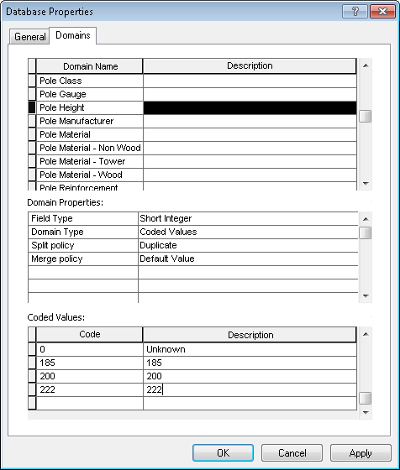~~
4. ~~Click OK to apply.~~

## ~~20067 Add New Members to Structure Size Domain~~

1. ~~Right click the database connection in ArcCatalog and select Properties.~~
2. ~~In the Domains tab, scroll to the Structure Size domain and select it.~~
3. ~~Scroll to the bottom and add the following new codes/values:  
     
   1/ 13” X 24”  
   2/ 17” X 30”  
   3/ 24” X 36”  
   4/ 30” X 48”  
   5/ 3’ X 5’  
   5E/ 3’ X 5’ with extension  
   6/ 4’ X 6’  
   6E/ 4’ X 6’ with extension  
   7/ 4’6” X 8’6”  
   7E/ 4’6” X 8’6” with extension  
   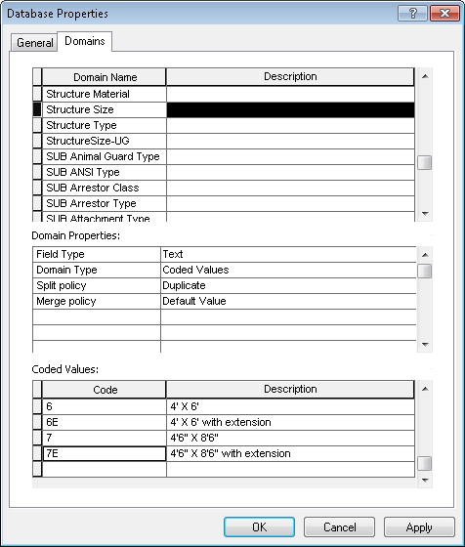~~
4. ~~Press OK to apply.~~

## ~~19516 New Value for Joint Pole Members Auburn PAR #89767~~

1. ~~Right click the database connection in ArcCatalog and select Properties.~~
2. ~~In the Domains tab, scroll to the Joint Pole Members domain and select it.~~
3. ~~Scroll to the bottom and add the following new code/value:  
   CX/Colfax Exchange  
   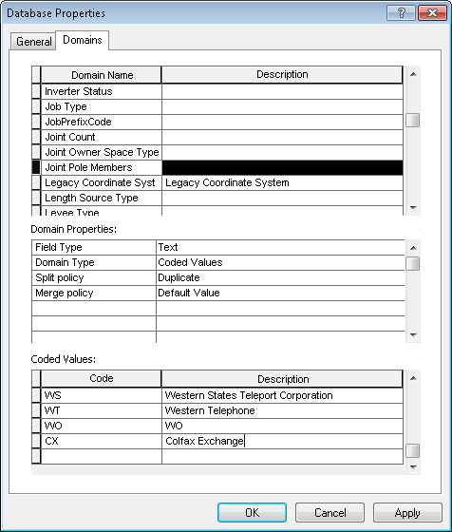~~
4. ~~Press OK to apply.~~

## ~~19469 PAR #86070 New Value for Secondary Voltage Domain~~

1. ~~Right click the database connection in ArcCatalog and select Properties.~~
2. ~~In the Domains tab, scroll to the Secondary Voltage domain and select it.~~
3. ~~Scroll to the bottom and add the following new code/value:  
   35, 125/216  
   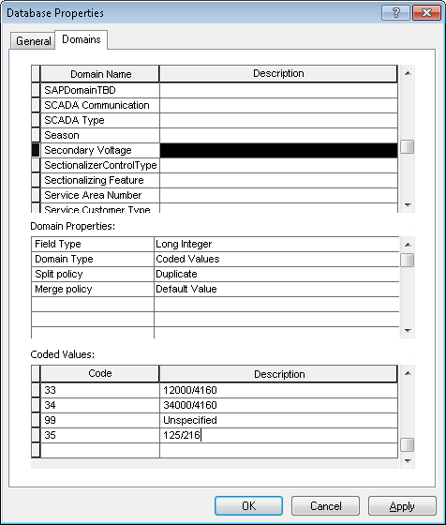~~
4. ~~Press OK to apply.~~

## ~~19468 Maintentance Plat/AreaName Field PAR SF #89311 PAR Diablo #88989~~

1. ~~In the CommonFeaturesDataset, right click MaintenancePlat and select Properties.~~
2. ~~In the Fields tab, scroll to the AREANAME field.~~
3. ~~Select the Alias property and rename it to “Region”.  
   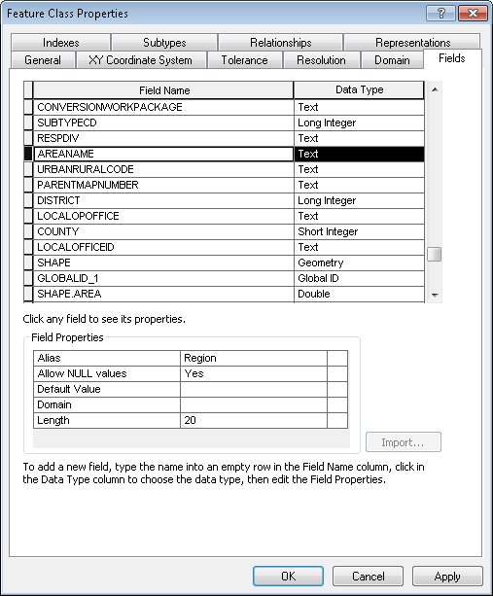~~
4. ~~Select the Subtypes tab.~~
5. ~~Select the 1 subtype and locate the AREANAME field.~~
6. ~~Assign the Region domain name to it.  
   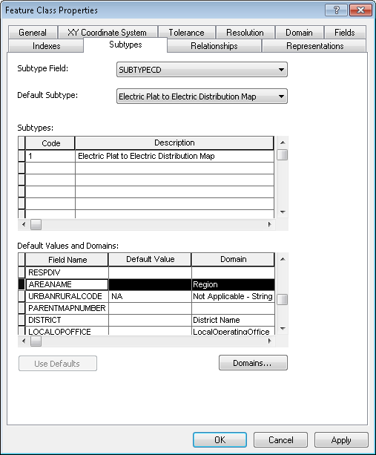~~
7. ~~Select OK to apply.~~
8. ~~Repeat the above steps for the PGE_LOPC feature class.~~

## ~~19105 Add '4000' value to RatedAmps Domain~~

1. ~~Right click the database connection in ArcCatalog and select Properties.~~
2. ~~In the Domains tab, scroll to the Rated Amps domain and select it.~~
3. ~~Scroll to the bottom and add the following new code/value:  
   4000/4000A  
   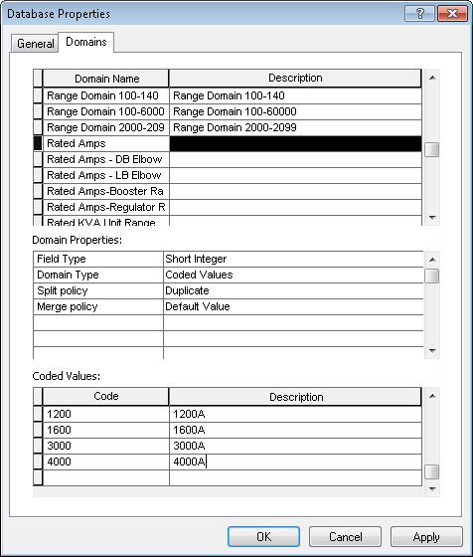~~
4. ~~Click OK to apply.~~

## ~~17716 CCB Interface Needed : Create new Domain for Essential Customer Indicator fields to use : "Essential Customer IDC and assign it to SERVICEPOINT.ESSENTIALCUSTOMERIDC~~

1. ~~Right click the database connection and select Properties.~~
2. ~~In the Domains tab, scroll to the bottom.~~
3. ~~Create a new domain with the following properties:  
   Name: Essential Customer IDC  
   Type: Text~~

~~Domain type: Coded values  
Split: Defaults~~

~~Merge: Defaults~~

1. ~~Type in the following codes/values in the bottom part of the screen:  
   N/"No"~~

~~Y/"Yes"~~

~~E/"Excluded from ROBC"~~

1. ~~Result:  
   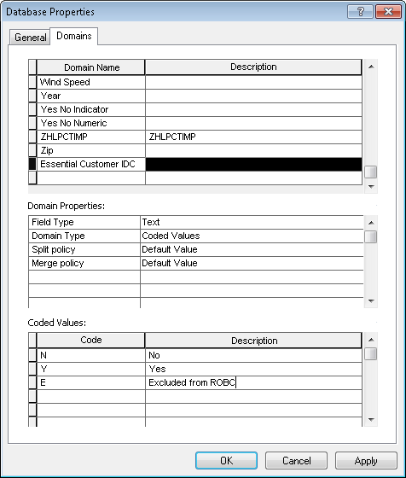~~
2. ~~Click OK to apply.~~

## 20488 Updates to the DuctDefinition DuctSize and ActualSize fields

1. ~~In the root of the database, right click the DuctDefinition table and select Properties.~~
2. ~~In the Fields tab, scroll to the DuctSize field.~~
3. ~~Select it and change the alias to “Draw Size”.  
   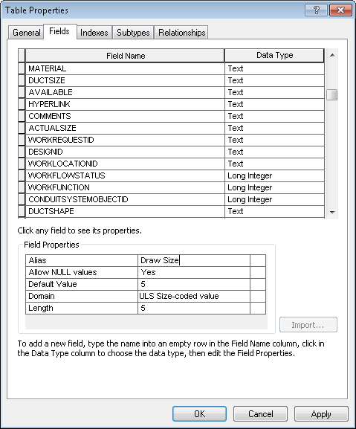~~
4. ~~Select the ACTUALSIZE field.~~
5. ~~Delete it and select Apply.~~
6. ~~Recreate it with the following properties:  
   ACTUALSIZE  
   Type: Text  
   Alias: Actual Size  
   Allow Nulls: Yes  
   Default: 5~~

~~Domain: ULS Size-coded value~~

~~Length: 5   
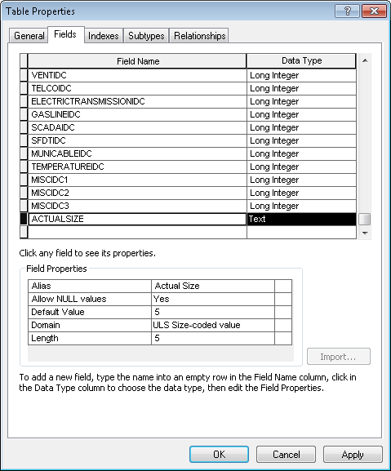~~

1. ~~Click OK to apply.~~
2. Right click the DuctDefinition table and select ArcFM Properties Manager.
3. In the Field Info tab, select the DuctSize field.
4. For the Custom Field Editor option, select the drop down and select “ArcFM Duct Size Editor”.  
   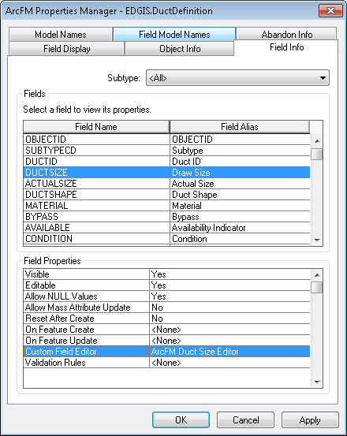
5. Select the ActualSize field.
6. Set the Custom Field Editor to ArcFM Duct Size Editor.
7. Select OK to apply.

## 20342 Make vent and fiber optic indicators visible on duct def (all subtypes)

1. In the root of the database, right click DuctDefinition and select ArcFM Properties Manager.
2. In the Field Info tab, select the Duct Bank subtype.
3. Select the FIBEROPTICIDC field and set Visible=Yes.
4. Select the VENTIDC field and set Visible=Yes.  
   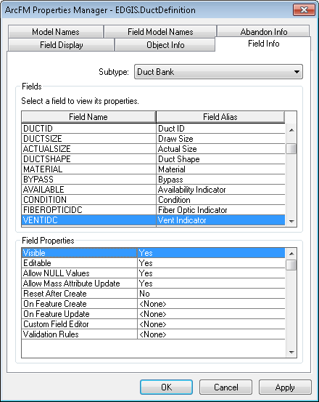
5. Repeat the above steps for the Conduit subtype.
6. Click OK to apply.

## 20532 Remove PGE Annotation Horizontal Alignment AU from On Update of 50 scale anno classes

1. In the ElectricDataset, right click CapacitorBank50Anno and select ArcFM Properties Manager.
2. In the Object Info tab, select the On Feature Update dropdown and click <Multiple>…
3. Unassign the PGE Horizontal Alignment AU, located here:  
   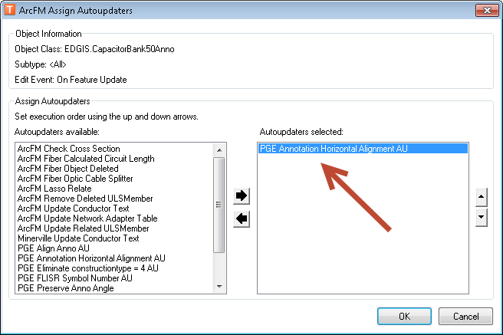
4. Unassign it by selecting it and then clicking the left-pointing arrow. The right side will not contain it after this step is completed.
5. Select OK and OK again to apply.
6. Repeat the above steps for the following feature classes:

* ConduitSystem50Anno
* CustAgreeNum50Anno
* DCConductor50Anno
* DCDevice50Anno
* DCRectifier50Anno
* DeliveryPoint50Anno
* DeviceGroup50Anno
* DistBusBar50Anno
* DynProtDevice50Anno
* FaultIndicator50Anno
* Fuse50Anno
* JobNumber50Anno
* NetworkProtector50Anno
* NeutralConductor50Anno
* PrimaryGenerator50Anno
* PriOHConductor50Anno
* PriUGConductor50Anno
* SecOhConductor50Anno
* SecGenerator50Anno
* SecUgConductor50Anno
* StepDown50Anno
* Streetlight50Anno
* Substation50Anno
* SubsurfaceStructure50Anno
* SupportStructure50Anno
* Switch50Anno
* Transformer50Anno
* VaultPoly50Anno
* VoltageRegulator50Anno

## 20459 Add CircuitColor field to tables

1. ~~Modify the attached python script to reference an appropriate sde connection file with the EDGIS user name and password saved and connecting to the desired database.  
   ~~
2. ~~Execute the modified python script. This will create a new domain called "PGE Circuit Color"~~
3. ~~Open ArcCatalog~~
4. ~~Connect to the desired database as the EDGIS user.~~
5. ~~Right click on the database connection and choose properties.~~
6. ~~Click the Domains tab.~~
7. ~~Select the "PGE ED Field Model Names" domain~~
8. ~~Add the "PGE_CircuitColor" code with a description of "PGE_CircuitColor"~~
9. ~~Right click on the EDGIS.CircuitSource table and choose properties.~~
10. ~~Select the Fields tab~~
11. ~~Add a new field~~
    1. ~~Field Name: CIRCUITCOLOR~~
    2. ~~Data Type: Text~~
    3. ~~Alias: Circuit Color~~
    4. ~~Allow NULL Values: Yes~~
    5. ~~Domain: PGE Circuit Color~~
    6. ~~Length: 50~~
12. ~~Click OK~~
13. ~~Repeat steps 9 - 12 for the EDGIS.PriOHConductor and EDGIS.PriUGConductor feature classes.~~
14. Right click on the EDGIS.CircuitSource table and choose "ArcFM Properties Manager"
15. Click on the Field Info tab.
16. Select the "CIRCUITCOLOR" field.
17. Set Visible to "Yes"
18. Choose the "PGE Circuit Color Picker" for the custom field editor.
19. Click Apply
20. Select the Model Names tab.
21. Add the "PGE_CircuitColor" model name
22. Click Apply
23. Click the "Field Model Names" tab.
24. Select the CIRCUITCOLOR field.
25. Add the "PGE_CircuitColor" field model name.
26. Click Apply->OK
27. Repeat steps 14 -> 26 for the EDGIS.PriOHConductor and EDGIS.PriUGConductor feature classes, but do not execute step 18 and for step 17 set visible to "No".
28. Initialize the new Circuit Color field by executing the sql statements in the attached InitialCircuitColorAssignment.txt file.



1. Right click on the EDGIS.PGE_CircuitColor table and choose delete (this table is no longer required as the colors are stored in the domain and on the circuit source table).

## 20540 Mark DistBusBar as non-traceable

1. In the ElectricDataset, right click DistBusBar and select ArcFM Properties Manager.
2. In the Field Model Names tab, select the Traceable field.
3. In the bottom half, select Electric Field Model Name from the dropdown.
4. Locate the FDRMGRNONTRACEABLE model name on the left hand side and double click it to apply. It should move to the right side.  
   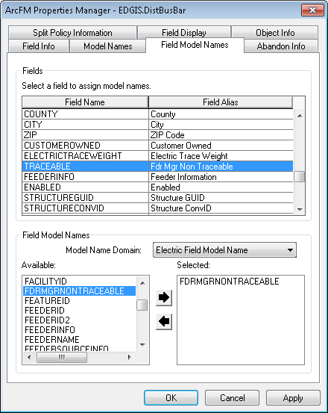
5. Press OK to apply.

## 20552 Update Duct feature class

1. In the UFMDataset, right click the Duct feature class and select ArcFM Properties Manager.
2. Apply the following properties to the fields in the feature class.
   1. For “make not visible”, select the field in the Field Info tab and set Visible=No.
   2. For “make not editable”, same as (a) but change Editable=No.
   3. For “Assign PGE_DUCTSYNCATTR field model name”, select the Field Model Names tab and assign the model name to the specified field.

* ObjectID (no change)
* PhaseDesignation - Make not visible
* HasSubducts - Make not visible
* DuctPosition - Make not editable
* DuctName - Make not visible
* DuctSize - Make not editable
* DuctShape - Make not editable; Assign PGE_DUCTSYNCATTR field MN
* Material - Make not editable
* Bypass - Make not editable
* Availability Indicator - Make not editable
* Occupied (no change)
* Condition - Make not editable
* Fiber Optic Indicator - Make not editable
* Vent Indicator - Make not editable
* Telco Indicator - Make not editable; Assign PGE_DUCTSYNCATTR field MN
* Elec Transmission Indicator - Make not editable; Assign PGE_DUCTSYNCATTR field MN
* Gas Line Indicator - Make not editable; Assign PGE_DUCTSYNCATTR field MN
* SCADA Indicator - Make not editable; Assign PGE_DUCTSYNCATTR field MN
* SF Dept. Technology Indicator - Make not editable; Assign PGE_DUCTSYNCATTR field MN
* Muni Cable Indicator - Make not editable; Assign PGE_DUCTSYNCATTR field MN
* Temperature Indicator - Make not editable; Assign PGE_DUCTSYNCATTR field MN
* Future 1 Indicator - Make not visible
* Future 2 Indicator - Make not visible
* Future 3 Indicator - Make not visible
* CreationUser (no change)
* DateCreated (no change)
* LastUser (no change)
* DateModified (no change)
* FacilityId - Make not editable
* Shape (no change)
* GlobalID - Make not visible
* ConversionWorkPackage - make not visible
* ConversionID - make not visible
* CustomerOwned - make not visible

1. In the Field Display tab, re-order the fields so that their order matches the order of the above fields.
2. Press OK to apply.
3. Right click the Duct feature class and select Properties.
4. In the Fields tab, scroll to the DuctSize field.
5. Select it and change the Alias to “Draw Size”.  
   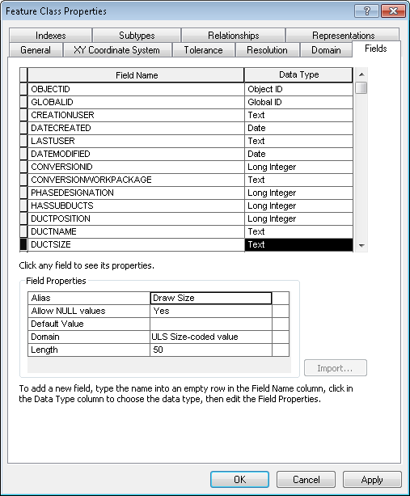
6. Press OK to apply.

## 20553 Add ActualSize field to Duct feature class

1. ~~In the UFMDataset, right click the Duct feature class and select Properties.~~
2. ~~In the Fields tab, scroll to the bottom of the list.~~
3. ~~Add a new field, ACTUALSIZE, with the following properties:~~

~~Name: ACTUALSIZE~~

~~Type: Text~~

~~Alias: Actual Size~~

~~Allow Nulls: Yes~~

~~Default Value: <null>~~

~~Domain: ULS size-coded value~~

~~Length: 5~~

~~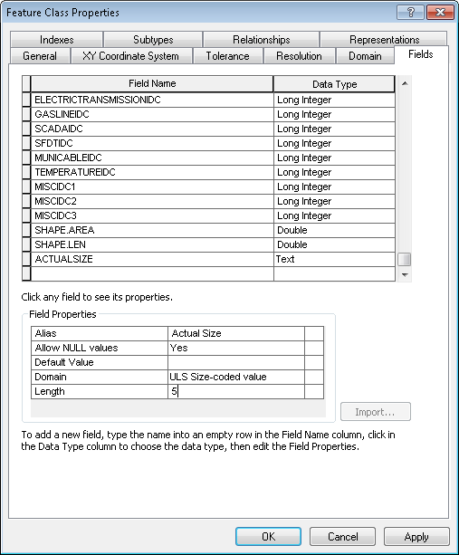~~

1. ~~Click OK to apply.~~
2. Right click the Duct feature class and select ArcFM Properties Manager.
3. In the Field Info tab, scroll to the ACTUALSIZE field and select it.
4. Set Visible=Yes.
5. Set Editable=No.  
   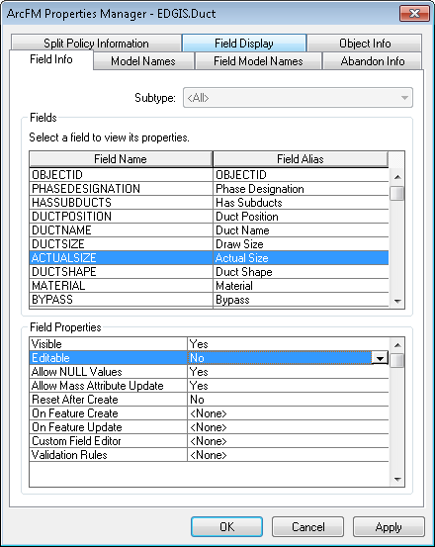
6. Select the Field Model Names tab.
7. Select the ACTUALSIZE field if not already selected.
8. In the bottom of the window, select the PGE Field Model Names domain from the dropdown.
9. On the left hand side, double click the PGE_DUCTSYNCATTR model name to apply it.  
   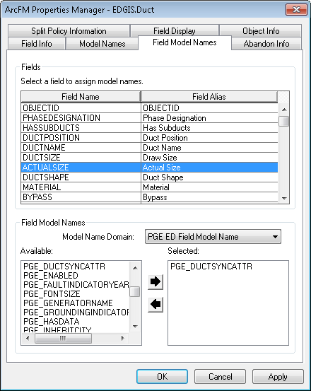
10. Select the Field Display tab.
11. Locate the ACTUALSIZE field and move it so that it is between DUCTSIZE (Draw Size) and DUCTSHAPE (Duct Shape).  
    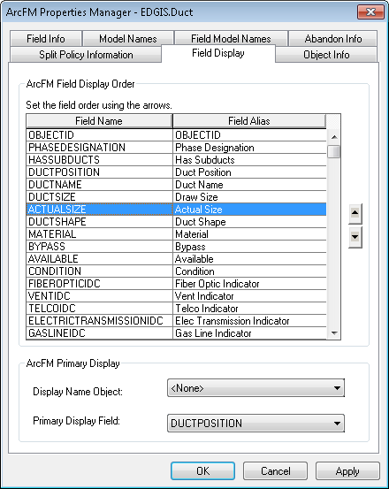

## 20572 Update Vault polygon ArcFM properties

1. Right click the database connection and select Properties.
2. In the Domains tab, scroll to the PGE ED Object Class Model Name domain and select it.
3. Scroll to the bottom of the domain in the lower half of the screen.
4. Add the following model name/description: PGE_VAULTPOLY/PGE_VAULTPOLY.  
   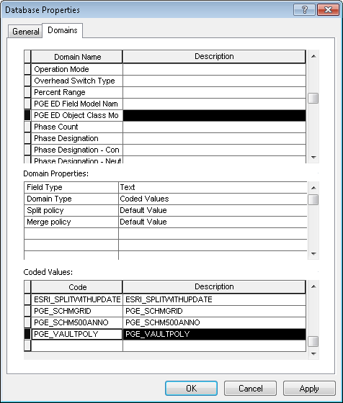
5. Click OK to apply.
6. In the ElectricDataset, right click the VaultPoly feature class and select ArcFM Properties Manager.
7. In the Model Names tab, assign the PGE_VAULTPOLY class model name to the feature class.

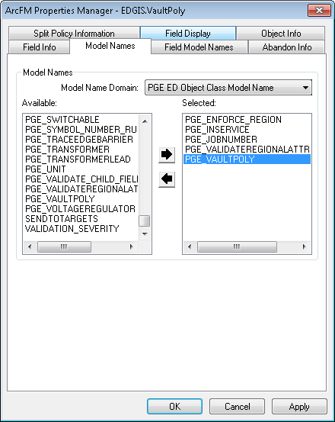

1. In the Field Model Names tab, scroll to the STRUCTURENUMBER field and select it.
2. Assign the PGE_STRUCTURENUMBER model name in the bottom of the window.  
   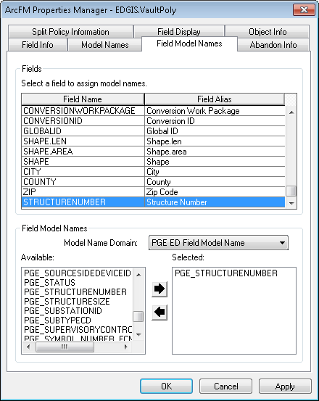
3. Press OK to apply.
4. Right click the SubsurfaceStructure feature class and select ArcFM Properties Manager.
5. Select the Object Info tab.
6. Select the On Feature Update dropdown and select <Multiple>…
7. Assign the PGE Sync Vault Poly AU.  
   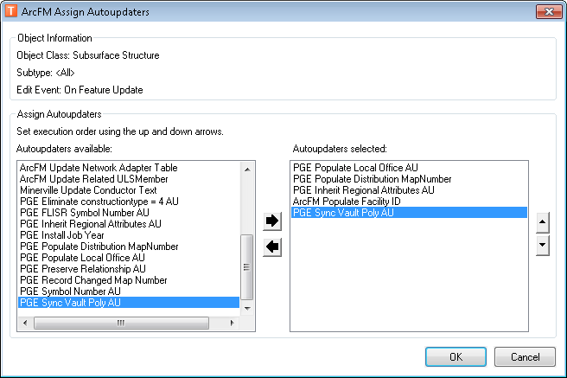
8. Select OK to apply.

## 20610 Update Conductor Insulation – UG domain to reduce EPR-HYP code value length

1. Copy the “insulation” folder inside the supporting documents linked from section 1.3 locally.
2. Inside it, edit the “00_set_env_vars.bat” file to specify the correct SDE file, database, username, and password.
3. Execute 0_change_field_with_data.bat and press enter when prompted if each step is successful.
4. Copy logs to a file and attach to TFS ticket.

## 20737 Remove ULSTEXTFIELD model name from LABELTEXT field of SecUgConductor

1. Right click the **SecUgConductor** in the Electric dataset and select **ArcFM Properties Manager**.
2. In the **Field Model Names** tab, navigate to the **LABELTEXT** Field.
3. Remove the **ULSTEXTFIELD** model name.

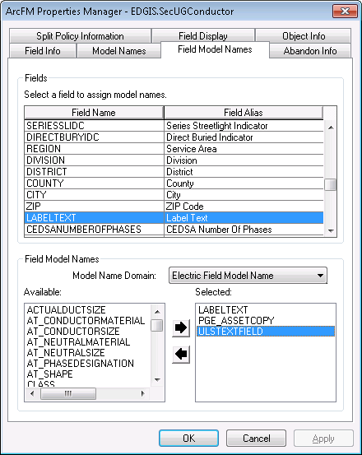

1. Click on **OK**.

## 20738 Update Switch Annotation

1. Right click the **SwitchAnno** in the Electric dataset and select **Properties**.
2. In the **Annotation Classes** tab, select the **Default** annotation class
3. Select the **Properties** button in the **Placement Properties** group
4. Select the **Fitting Strategy** tab
5. Select **Options** adjacent to the **Stack Label** checkbox

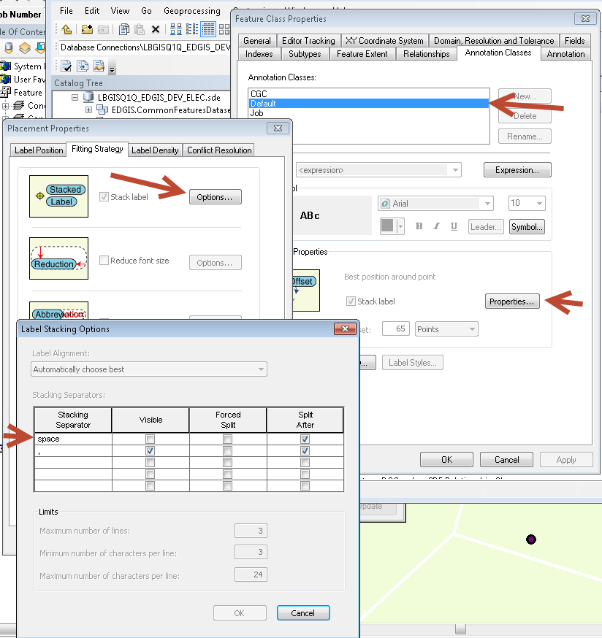

1. Uncheck the **After Split** checkbox (and any other checked checkboxes, if any) in the row with “space” specified for the Stacking Separator
2. Delete the text “space” from the **Stacking Separator** column
3. Click on **OK**
4. Re-open the **Options** dialog box and validate that the space row has been removed.

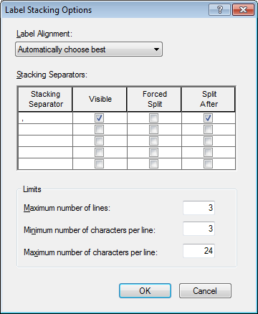

1. Repeat steps 1-9 for the **Switch50Anno** feature class

## 20752 Create PGE_CODES_AND_DESCRIPTIONS table for CYME

1. Connect to SQL plus as user edgis and run the following script to create the PGE_CODES_AND_DESCRIPTIONS table:

create table PGE_CODES_AND_DESCRIPTIONS( DOMAIN_NAME NVARCHAR2(200),CODE NVARCHAR2(200),DESCRIPTION NVARCHAR2(200));

1. Assign Select permissions using the following script:

grant SELECT on PGE_CODES_AND_DESCRIPTIONS to bo;

grant SELECT on PGE_CODES_AND_DESCRIPTIONS to public;

## ~~20060 Create New Domain: FI and LS Models~~

1. ~~Right click the database connection in ArcCatalog and select~~ **~~Properties~~**~~.~~
2. ~~In the~~ **~~Domains~~** ~~tab, scroll to the end and add a new Domain as follows:~~

~~Name: FI and LS Models~~

~~Field Type: Text~~

~~Domain Type: Coded Values~~

~~Split policy: Default Value~~

~~Merge policy: Default Value~~

1. ~~In the~~ **~~Coded Values~~** ~~section, enter the following code/value pairs:~~

|  |  |
| --- | --- |
| **~~Code~~** | **~~Description~~** |
| ~~MM3~~ | ~~MM3~~ |
| ~~LHMV~~ | ~~Lighthouse MV~~ |
| ~~A360~~ | ~~Autoranger 360~~ |
| ~~NLM~~ | ~~Navigator LM~~ |
| ~~LT~~ | ~~Load Tracker LP~~ |
| ~~HUG~~ | ~~Horstman Underground~~ |

1. ~~Click on~~ **~~OK~~**

## ~~20062 Add new Device Manufacturers to Device Manufacturer Domain~~

1. ~~Right click the database connection in ArcCatalog and select~~ **~~Properties~~**~~.~~
2. ~~In the~~ **~~Domains~~** ~~tab, scroll to the~~ **~~Device Manufacturer~~** ~~domain.~~
3. ~~In the~~ **~~Coded Values~~** ~~section, enter the following code/value pairs:~~

|  |  |
| --- | --- |
| **~~Code~~** | **~~Description~~** |
| ~~HM~~ | ~~Horstmann~~ |
| ~~SL~~ | ~~Schweitzer Engineering Labs~~ |
| ~~SE~~ | ~~Sentient~~ |
| ~~SS~~ | ~~Silver Spring Networks~~ |
| ~~TG~~ | ~~Tollgrade~~ |

1. ~~Click on~~ **~~OK~~**

## 2~~0063 Add new Members to the SCADA Communication Domain~~

1. ~~Right click the database connection in ArcCatalog and select~~ **~~Properties~~**~~.~~
2. ~~In the~~ **~~Domains~~** ~~tab, scroll to the~~ **~~SCADA Communication~~** ~~domain.~~
3. ~~In the~~ **~~Coded Values~~** ~~section, enter the following code/value pairs:~~

|  |  |
| --- | --- |
| **~~Code~~** | **~~Description~~** |
| ~~CELL~~ | ~~Cellular~~ |
| ~~OTH~~ | ~~Other~~ |

1. ~~Click on~~ **~~OK~~**

## ~~20065 Add New Members to the Actuating Current Values Domain~~

1. ~~Right click the database connection in ArcCatalog and select~~ **~~Properties~~**~~.~~
2. ~~In the~~ **~~Domains~~** ~~tab, scroll to the~~ **~~Actuating Current Value~~** ~~domain.~~
3. ~~In the~~ **~~Coded Values~~** ~~section, enter the following code/value pairs:~~

|  |  |
| --- | --- |
| **~~Code~~** | **~~Description~~** |
| ~~15~~ | ~~15-Amp~~ |
| ~~20~~ | ~~20-Amp~~ |
| ~~300~~ | ~~300-Amp~~ |

1. ~~Click on~~ **~~OK~~**

## ~~20047 Communicating Fault Indicator and Line Sensor~~

1. ~~Right click the~~ **~~Fault Indicator~~** ~~in the Electric dataset and select~~ **~~Properties~~**~~.~~
2. ~~In the~~ **~~Subtypes~~** ~~tab, enter in two new subtypes as follows:~~

~~Code 2, Description: “Communicating FI”~~

~~Code 3, Description: “Line Sensor”~~

~~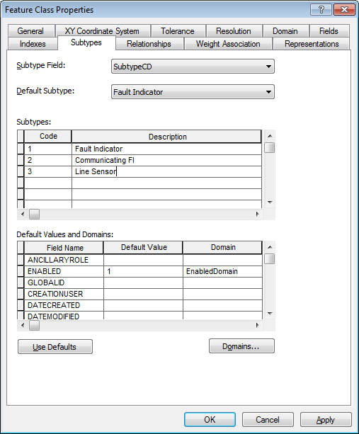~~

1. ~~Click on~~ **~~Apply~~**
2. ~~Switch to the~~ **~~Fields~~** ~~tab~~
3. ~~At the bottom, add the following new fields:~~

|  |  |  |  |  |  |
| --- | --- | --- | --- | --- | --- |
| **~~Name~~** | **~~Alias~~** | **~~Data Type~~** | **~~Length~~** | **~~Allow Nulls~~** | **~~Domain~~** |
| ~~MINREQLINEAMPS~~ | ~~Minimum Required Line Current~~ | ~~Short Integer~~ | ~~6~~ | ~~Yes~~ |  |
| ~~MAXRATEDAMPS~~ | ~~Maximum Rated Current~~ | ~~Short Integer~~ | ~~6~~ | ~~Yes~~ |  |
| ~~MANUFACTURER~~ | ~~Device Manufacturer~~ | ~~Text~~ | ~~40~~ | ~~Yes~~ | ~~Device Manufactuer~~ |
| ~~MODELA~~ | ~~Device Model A~~ | ~~Text~~ | ~~40~~ | ~~Yes~~ | ~~FI and LS Models~~ |
| ~~MODELB~~ | ~~Device Model B~~ | ~~Text~~ | ~~40~~ | ~~Yes~~ | ~~FI and LS Models~~ |
| ~~MODELC~~ | ~~Device Model C~~ | ~~Text~~ | ~~40~~ | ~~Yes~~ | ~~FI and LS Models~~ |
| ~~COMMUNICATION~~ | ~~Communication Platform~~ | ~~Text~~ | ~~20~~ | ~~Yes~~ | ~~SCADA Communication~~ |
| ~~CELLULARPROVIDER~~ | ~~Cellular Provider~~ | ~~Text~~ | ~~40~~ | ~~Yes~~ | ~~Carrier~~ |
| ~~MACADDRESSA~~ | ~~MAC Address A~~ | ~~Text~~ | ~~20~~ | ~~Yes~~ |  |
| ~~MACADDRESSB~~ | ~~MAC Address B~~ | ~~Text~~ | ~~20~~ | ~~Yes~~ |  |
| ~~MACADDRESSC~~ | ~~MAC Address C~~ | ~~Text~~ | ~~20~~ | ~~Yes~~ |  |
| ~~NETWORKOPSTATE~~ | ~~Network Operational State~~ | ~~Text~~ | ~~10~~ | ~~Yes~~ | ~~Active Indicator~~ |
| ~~SERIALNUMBERB~~ | ~~Serial Number B~~ | ~~Text~~ | ~~25~~ | ~~Yes~~ |  |
| ~~SERIALNUMBERC~~ | ~~Serial Number C~~ | ~~Text~~ | ~~25~~ | ~~Yes~~ |  |
| ~~BATTERYDATEB~~ | ~~Battery Date B~~ | ~~Date~~ |  | ~~Yes~~ |  |
| ~~BATTERYDATEC~~ | ~~Battery Date C~~ | ~~Date~~ |  | ~~Yes~~ |  |
| ~~YEARMANUFACTUREDB~~ | ~~Year Manufactured B~~ | ~~Short Integer~~ | ~~5~~ | ~~Yes~~ | ~~Year~~ |
| ~~YEARMANUFACTUREDC~~ | ~~Year Manufactured C~~ | ~~Short Integer~~ | ~~5~~ | ~~Yes~~ | ~~Year~~ |

1. ~~Click on~~ **~~Apply~~**
2. ~~Select and update the Alias on the following fields:~~

|  |  |  |
| --- | --- | --- |
| **~~Name~~** | **~~Old Alias~~** | **~~New Alias~~** |
| ~~SERIALNUMBER~~ | ~~Serial Number~~ | ~~Serial Number A~~ |
| ~~BATTERYDATE~~ | ~~Battery Date~~ | ~~Battery Date A~~ |
| ~~YEARMANUFACTURED~~ | ~~Year Manufactured~~ | ~~Year Manufactured A~~ |

## 20855 Configure Neutral Conductor for X-Section Anno

1. Right click the **NeutralConductor** in the Electric dataset and select **ArcFM Properties Manager**
2. On the **Model Names** tab, assign the PGE_NEUTRALCONDUCTOR model name from the PGE ED Object Class Model Name domain

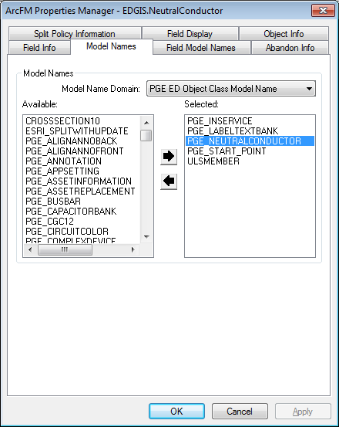

1. On the **Field Model Names** tab, assign the **LABELTEXT2** field from the PGE ED Field Model Name domain to the **LABELTEXT2** field

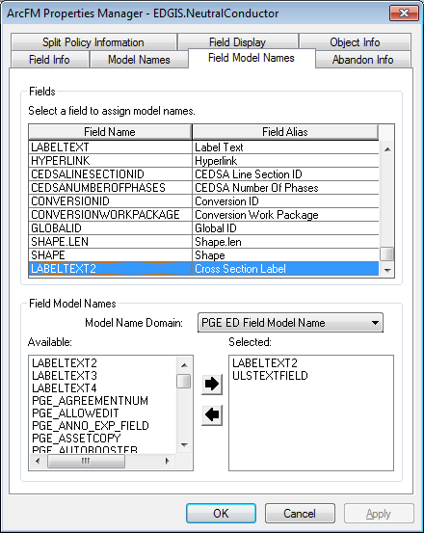

1. On the **Object Info** tab, assign the **ArcFM Check Cross Section** AU to the On Update event of the NeutralConductor to be the last AU to execute

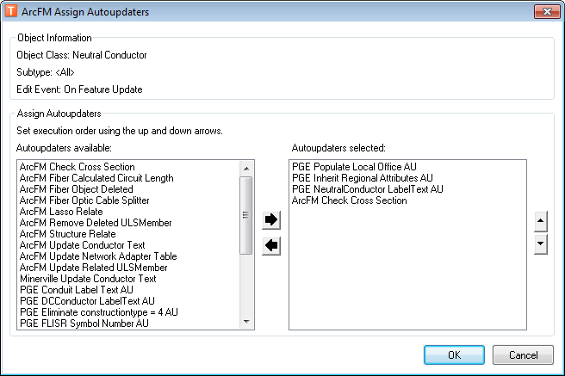

1. Click **OK**
2. Click **OK**

## 20611 Add new Source Side Device Fields and Configure

1. ~~Modify the attached python script's DataConnection to reference an SDE connection file to the desired database with the edgis user name and password saved in it.~~

~~~~

1. ~~Execute the python script and report if any errors are thrown. This must be run with no one else in the system or it will fail due to database locks~~
2. ~~Open ArcCatalog and connect to the desired database as the edgis user~~
3. ~~Right click on the database connection and choose properties~~
4. ~~Click the domains Tab~~
5. ~~Select the "PGE ED Field Model Name" domain~~
6. ~~Add the following Code,Description items~~

* ~~PGE_PROTECTIVESSD, PGE_PROTECTIVESSD~~
* ~~PGE_AUTOPROTECTIVESSD, PGE_AUTOPROTECTIVESSD~~

1. ~~Click Apply -> Ok~~
2. Right click on the EDGIS.CapacitorBank and select "ArcFM Properties Manager"
3. Click on the field model names tab
4. Select the ProtectiveSSD field
5. Add the PGE_ProtectiveSSD field model name
6. Select the AutoProtectiveSSD field
7. Add the PGE_AutoProtectiveSSD field model name
8. Click Apply -> OK
9. Repeat steps 9-15 for the following feature classes

* EDGIS.DCRectifier
* EDGIS.DynamicProtectiveDevice
* EDGIS.FaultIndicator
* EDGIS.Fuse
* EDGIS.OpenPoint
* EDGIS.SmartMeterNetworkDevice
* EDGIS.StepDown
* EDGIS.Switch
* EDGIS.Tie
* EDGIS.Transformer
* EDGIS.VoltageRegulator

## 20420 Remove ArcFM Structure Relate from DCRectifier and DistBusBar

1. Open ArcCatalog and connect to the desired database
2. Browse to the **EDGIS.DistBusBar** feature class
3. Right Click and choose "**ArcFM Properties Manager**"
4. Click on the **Object Info** tab.
5. Click the down arrow for the "**On Feature Create**" and select Multiple.
6. Remove the "**ArcFM Structure Relate**" autoupdater from the right hand side and click OK.
7. Repeat steps 6 for the "On Feature Update"

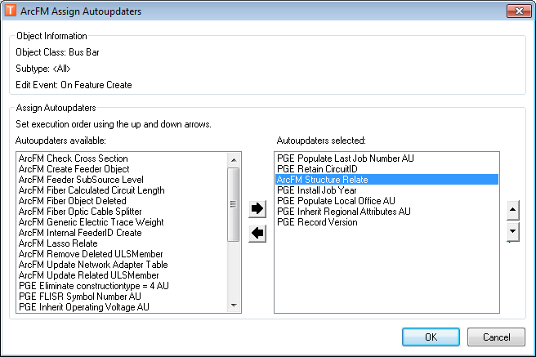

1. Click Apply -> OK
2. Repeat steps 2 - 8 for the **DCRectifier** class

## 20558 Update Cached Tracing Tables

1. Log in via sql plus as the edgis user to the desired Electric database.
2. Execute the following sql script:

\\sfetgis-nas01\sfgispoc_data\ApplicationDevelopment\IBM_Delivery\10.2.1\Releases\Cached Tracing\10.2.1.1\EDCachedTracing.sql

1. Log in via sql plus as the edgis user to the desired substation database.
2. Execute the following sql script

\\sfetgis-nas01\sfgispoc_data\ApplicationDevelopment\IBM_Delivery\10.2.1\Releases\Cached Tracing\10.2.1.1\SUBCachedTracing.sql

## 20589 ED50 Configuration for Network Protector

1. Connect to the desired database via arccatalog as the edgis user
2. Right click on the **EDGIS.NetworkProtector** feature class and select ArcFM Properties Manager.
3. Click on the **Field Model Names** tab
4. Click the **Status** field
5. Add the "**PGE_DMSField**" model name.

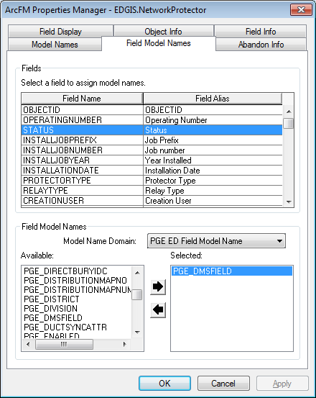

1. Click **OK**

## 20768 Modify ArcFM Properties to support Circuit ID UI

1. Log in to the EDER database via ArcCatalog as the EDGIS user
2. Right click on the "EDGIS.CircuitSource" table and choose "ArcFM Properties Manager"
3. Select the "Field Info" tab.
4. Select the CircuitID field and choose the "PGE Circuit ID Picker" as the Custom Field Editor and apply
5. Click SubstationID field and set Editable to false and apply
6. Click the FeederID field and set Editable to false and apply
7. Click the Division field and set Editable to false and apply
8. Click Apply->Okay
9. ~~Right click on the Database connection and choose properties~~
10. ~~Select the "PGE ED Field Model Name" domain~~
11. ~~Add the following Code,Description values~~

* ~~PGE_SUBSTATIONID, PGE_SUBSTATIONID~~
* ~~PGE_SUBSTATIONNAME, PGE_SUBSTATIONNAME~~

1. ~~Click Apply~~
2. ~~Select the "PGE ED Object Class Model Name" domain~~
3. ~~Add the following code,description~~

* ~~PGE_SUBSTATION~~

1. ~~Click Apply~~
2. Right click on the "EDGIS.Substation" feature class and choose "ArcFM Properties Manager"
3. Select the model names tab
4. Add the "PGE_SUBSTATION" model name
5. Click Apply
6. Select the "Field Model Names" tab
7. Select the "Name" field and assign the "PGE_SUBSTATIONNAME" field model name
8. Select the "STATIONNUMBER" field and assign the "PGE_SUBSTATIONID" field model name
9. Click Apply -> OK

## 20594 Map Production 1.0 at 10.2.1

1. Execute the steps in [TFS 20594](http://edappgistfsprd1:8080/tfs/ElectricDistCollection/EDAMGIS/_workitems#_a=edit&id=20594)

## PGEDATA SCHEMA : Need to increase field FEATURE_CLASS_NAME length to 65 on PGEDATA.PGEDATA_SM_FC _LAYER_MAPPING

1. Connect as PGEDATA user in the database to be updated using sqlplus:

e.g. sqlplus pgedata/<password>@lbgisq1q

1. Run sql to alter the table:
   1. ALTER TABLE PGEDATA.PGEDATA_SM_FC_LAYER_MAPPING MODIFY (FEATURE_CLASS_NAME NVARCHAR2(65));

1. Exit sqlplus:
   1. e.g. exit;

## 21730 Alter TransformerAnno and remove Space and Comma as characters that cause \r\n for expressions

        1. Right click the TransformerAnno in the Electric dataset and select Properties.  
2.  In the Annotation Classes tab, select the Default annotation class  
3.  Select the Properties button in the Placement Properties group  
4.  Select the Fitting Strategy tab  
5.  Select Options adjacent to the Stack Label checkbox  
6.  Uncheck the After Split checkbox (and any other checked checkboxes, if any) in the row with "space" or "," specified for the Stacking Separator  
7a.  Delete the text "space" from the Stacking Separator column  
7b.  Delete the text "," from the Stacking Separator column  
8.    Click on OK  
9.    Re-open the Options dialog box and validate that the space row has been removed.  
10.  Repeat steps 1-9 for all Annotation Classes in Transformer  
11.  Repeat steps 1-10 for the Transformer50Anno feature class

## Update Data Model Version Table

**Database Configuration:**

1. Open SQL Plus.
2. Log in using the same server and user as was used in section 2.1.  
     
   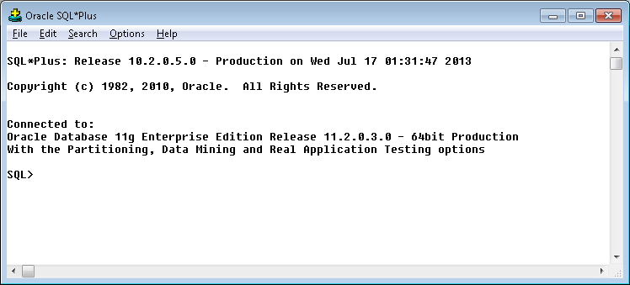
3. Run the SQL below:

update pgedatamodelversion set currentidc='N' where currentidc='Y';

insert into pgedatamodelversion (OBJECTID, CURRENTIDC, DATEAPPLIED, APPLIEDBYPERSONNAME, MODELVERSION) values (**INSERT NEXT VALID ID**,'Y',sysdate,'**<INSERT TEAM MEMBER DONE BY>**','**9.6** GOLD **CR20108**');

 commit;

# Schematics

## Open a Database Connection in ArcCatalog

1. Open ArcCatalog.
2. Within the Catalog Tree, expand “Database Connections” and open the active connection for this process. This is the connection that is referenced in the change request associated with this document (EDGIS<DB name in the format X#Y> )

## 20851 Create Circuit Color field on PriOhConductor and PriUGConductor

1. Execute the steps in the attached document:



## 20933 Populate Circuit Color for Primary Conductors

1. Open a command prompt window
2. Record the directory you are in, if you are not in a directory where you can create a file, then using the CD command change directories to somewhere a file may be created for example "CD C:\Temp"
3. Use the sqlplus command to connect to the system publication database EDGISP1P database

sqlplus edgis/edgis!Q1Qi@LBGISQ1Q

1. Use the following commands to create a file in the current directory of the command window:

set trimspool on

set linesize 5000

set pagesize 0

spool information_update_circuitcolors_PRIOH.sql

select 'update edgis.SCH1601E_PRIOHCONDUCTOR set circuitcolor='''||CIRCUITCOLOR||''' where UGUID='''||GLOBALID||''' ;' from edgis.priohconductor where circuitcolor is not null ;

select 'update edgis.SCH1601E_PRIUGCONDUCTOR set circuitcolor='''||CIRCUITCOLOR||''' where UGUID='''||GLOBALID||''' ;' from edgis.priugconductor where circuitcolor is not null ;

1. Now that the file has been created type in exit to get back to a command prompt:

exit

1. Open the file in an editor by browsing to the directory
2. Connect to the target database to update with the new file information:

sqlplus edgis/edgis!MA1De@EDSCMA1D

1. Copy and paste the update command lines from the file into the command prompt.
2. Type "Commit;" after the commands have run to commit the updates to the database:
3. Exit the sqlplus and command prompt

## Update Data Model Version Table

**Database Configuration:**

1. Open SQL Plus.
2. Log in using the same server and user as was used in section 3.1.  
     
   
3. Run the SQL below:

update pgedatamodelversion set currentidc='N' where currentidc='Y';

insert into pgedatamodelversion (OBJECTID, CURRENTIDC, DATEAPPLIED, APPLIEDBYPERSONNAME, MODELVERSION) values (**INSERT NEXT VALID ID**,'Y',sysdate,'**<INSERT TEAM MEMBER DONE BY>**','**9.6** GOLD **CR20108**');

commit;

# Known Issues

<Please List any other issues encountered here while following the document>